**ASSIGNMENT 2**

ROLL NO:19BIT100

NAME: MAHASRI M

1)SALES BY CUSTOMER

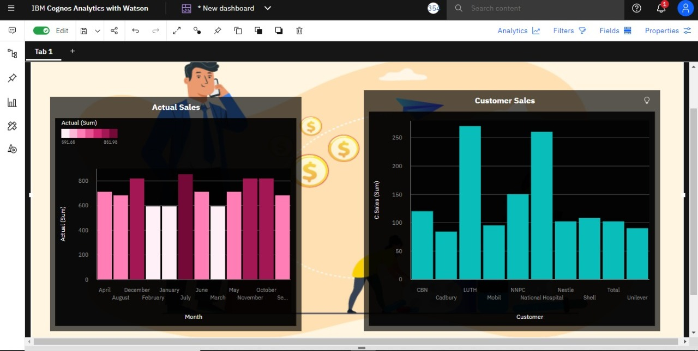

2)SALES BY LOCATION

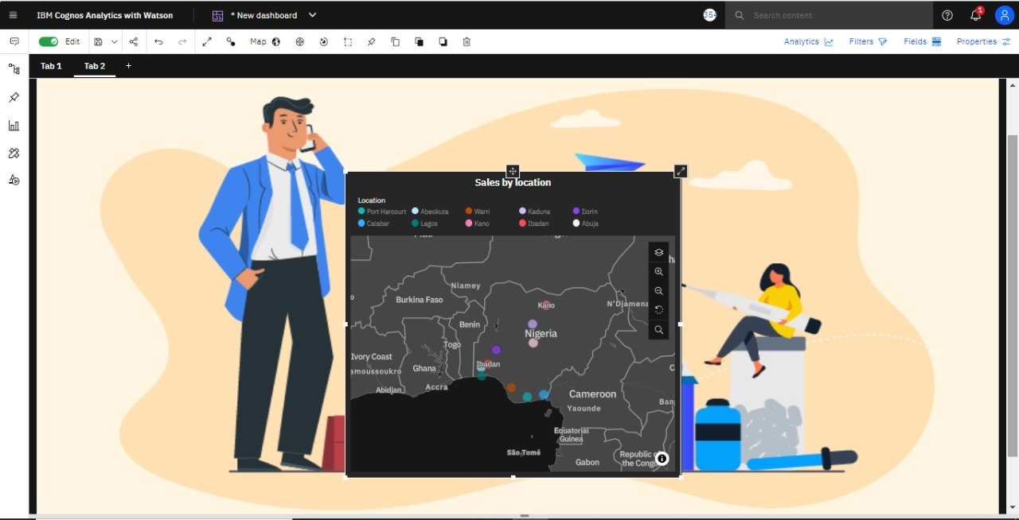

3)SALES BY SALES REPRESENTATIVE

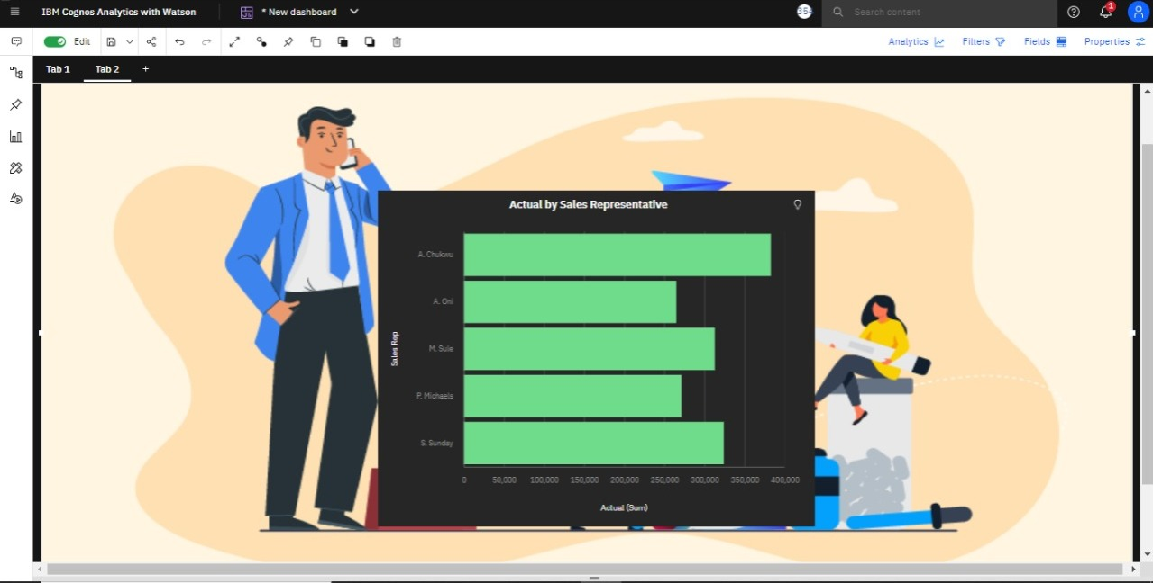

4)RECEIVED INVENTORY FROM SUPPLIER

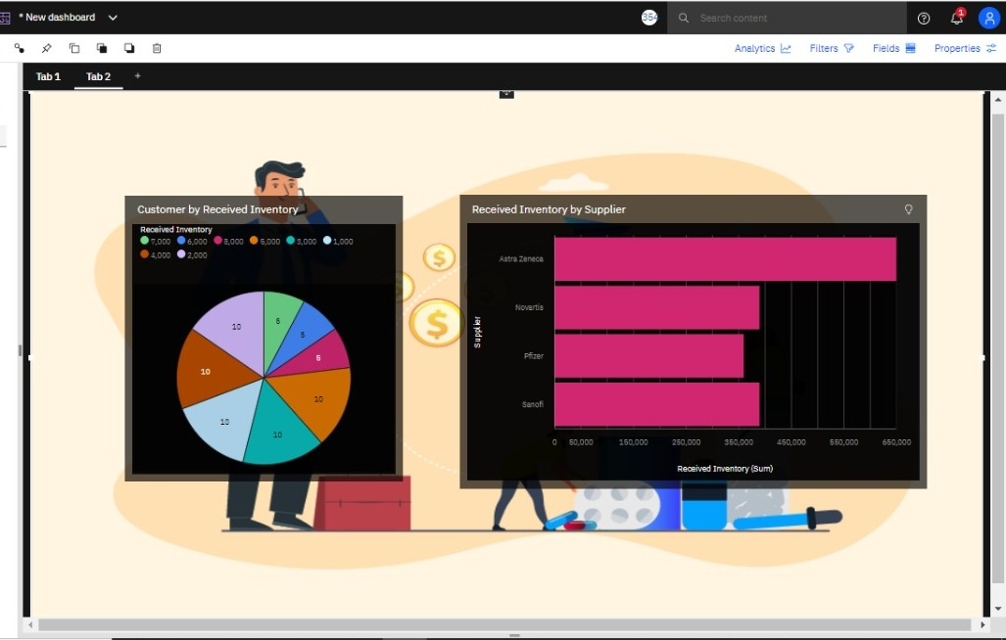

5)INVENTORY STOCK FOR WAREHOUSE LOCATIONS

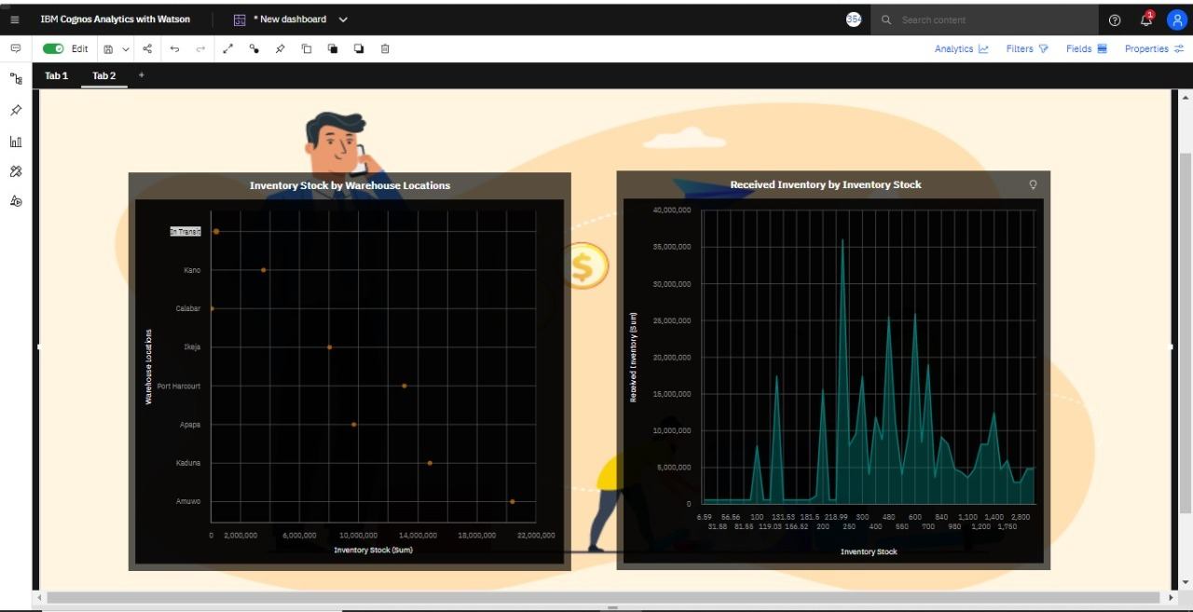

6)SALES TREND

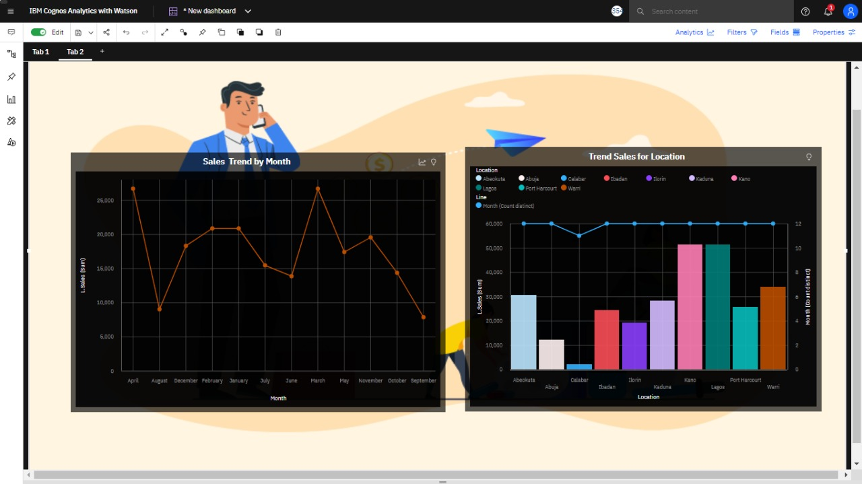

7)MONTHLY SALES

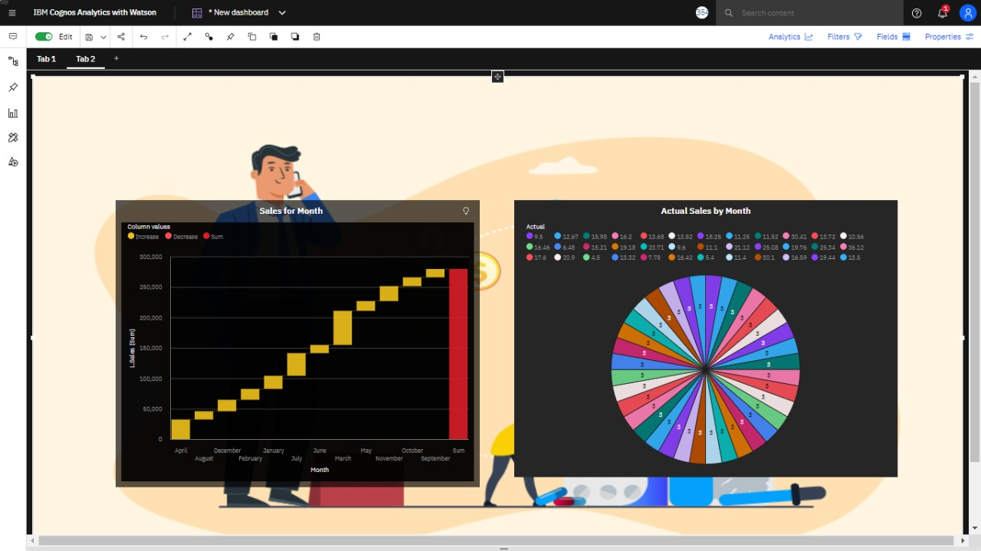

8)ACTUAL AND RECEIVED INVENTORY BY MONTH

